
Data Structures and Algorithms (23CSE203)
LAB MANUAL
Submitted By:

Name | R . Hasini shekhar
Roll No | AV.SC.U4CSE25146
Year/Sem/Section | 2nd YEAR/SEM-3/CSE-B
Date of Submission:
Submitted To:
Name | Dr. Raj Kumar Batchu
Department | CSE
Designation | Assistant Professor (Sl. Gr) School of Computing

MARKS

S. No | TITLE | PAGE NO | REMARKS
1. | 1(A) Aim:  A rocket launch system displays countdown before launch . Using recursion write python program to display countdown to 1 followed by launch.  1(B) Aim:  Write a python program to calculate compound interest by taking user input.  1(C) Aim:  HR Department stores Employee Id’s in a list develop a recursive program in python to search for a given employee Id in the list.  1(D) Aim:  Develop a python program to print 1st n terms of Fibonacci series.  1(E) Aim:  Develop a python program to calculate factorial of a given number. | 8-15
2. | 2(A) Aim:  Write a python program to implement linear search.  2(B)(i) Aim: Write a python program to implement binary search with sorted array as input.  (ii) Aim: Write a python program to implement binary search with unsorted array as input. | 16 - 21
3. | 3(A) Aim:  Write a python program to apply insertion sort where input elements are taken from the user .  3(B) Aim:  Write a python program to apply bubble sort where input elements are taken from the user .  3(C) Aim:  Write a python program to apply selection sort where input elements are taken from the user . | 22 – 24
4. | 4(A) Aim:  4(A) Aim:  write a python program to implement merge sort, where the elements are taken from user.  4(B) Aim:  write a python program to implement quick sort, where the elements are taken from user.
5. | 5(A) Aim:  Write a python program to implement a single linked list with the below operations:  A. create linked list  B. insert at beginning  C. Insert at end  D. Insert at index  E. Delete by value  F. Delete first node  G. Delete last node  H. Count number of nodes I. Display/traverse  J. exit  5(B) Aim:  Write a python program to implement a double linked list with the below operations:  A. create linked list  B. insert at beginning  C. Insert at end  D. Insert at index  E. Delete by value  F. Delete first node  G. Delete last node  H. Count number of nodes  I. Display/traverse  J. exit  5(C) Aim  Write a python program to implement a circular linked list with the below operations:  A. create linked list  B. insert at beginning  C. Insert at end  D. Insert at index  E. Delete by value  F. Delete first node  G. Delete last node  H. Count number of nodes  I. Display/traverse  J. exit
6. | 6(A) Aim  Write a python program to implement stack operations such as push, pop, peek, display using an linked list.  6(B) Aim  Write a python program to implement stack operations such as push, pop, peek, display using array.
7. | 7(A) Aim  Write a python program to implement queue and its operations such as enqueue, dequeue, peek and display with a menu driven approach using an array.  7(B) Aim  Write a python program to implement queue and its operations such as enqueue, dequeue, peek and display with a menu driven approach using linked list.  7(C) Aim  Write a python program to implement circular queue and its operations such as enqueue, dequeue, peek and display with a menu driven approach using an array.  7(D) Aim  Write a python program to implement circular queue and its operations such as enqueue, dequeue, peek and display with a menu driven approach using linked list.
8.

9.

LAB-1:
1.)Basic Programs Using Recursions :
A.) Aim: A rocket launch system displays countdown before launch . Using recursion write python program to display countdown to 1 followed by launch.
Program:
def rocket_countdown(n):
if n == 0:
print("LAUNCHED! ")
return
print(n)
rocket_countdown(n - 1)
start_num = int(input("Enter starting countdown number: "))

print("\n--- Starting Countdown ---")
rocket_countdown(start_num)

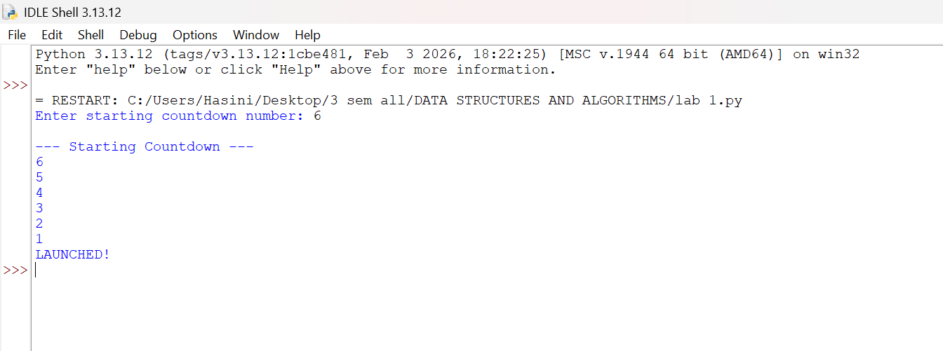
Output(+Ve Case):

Output(-Ve Case):
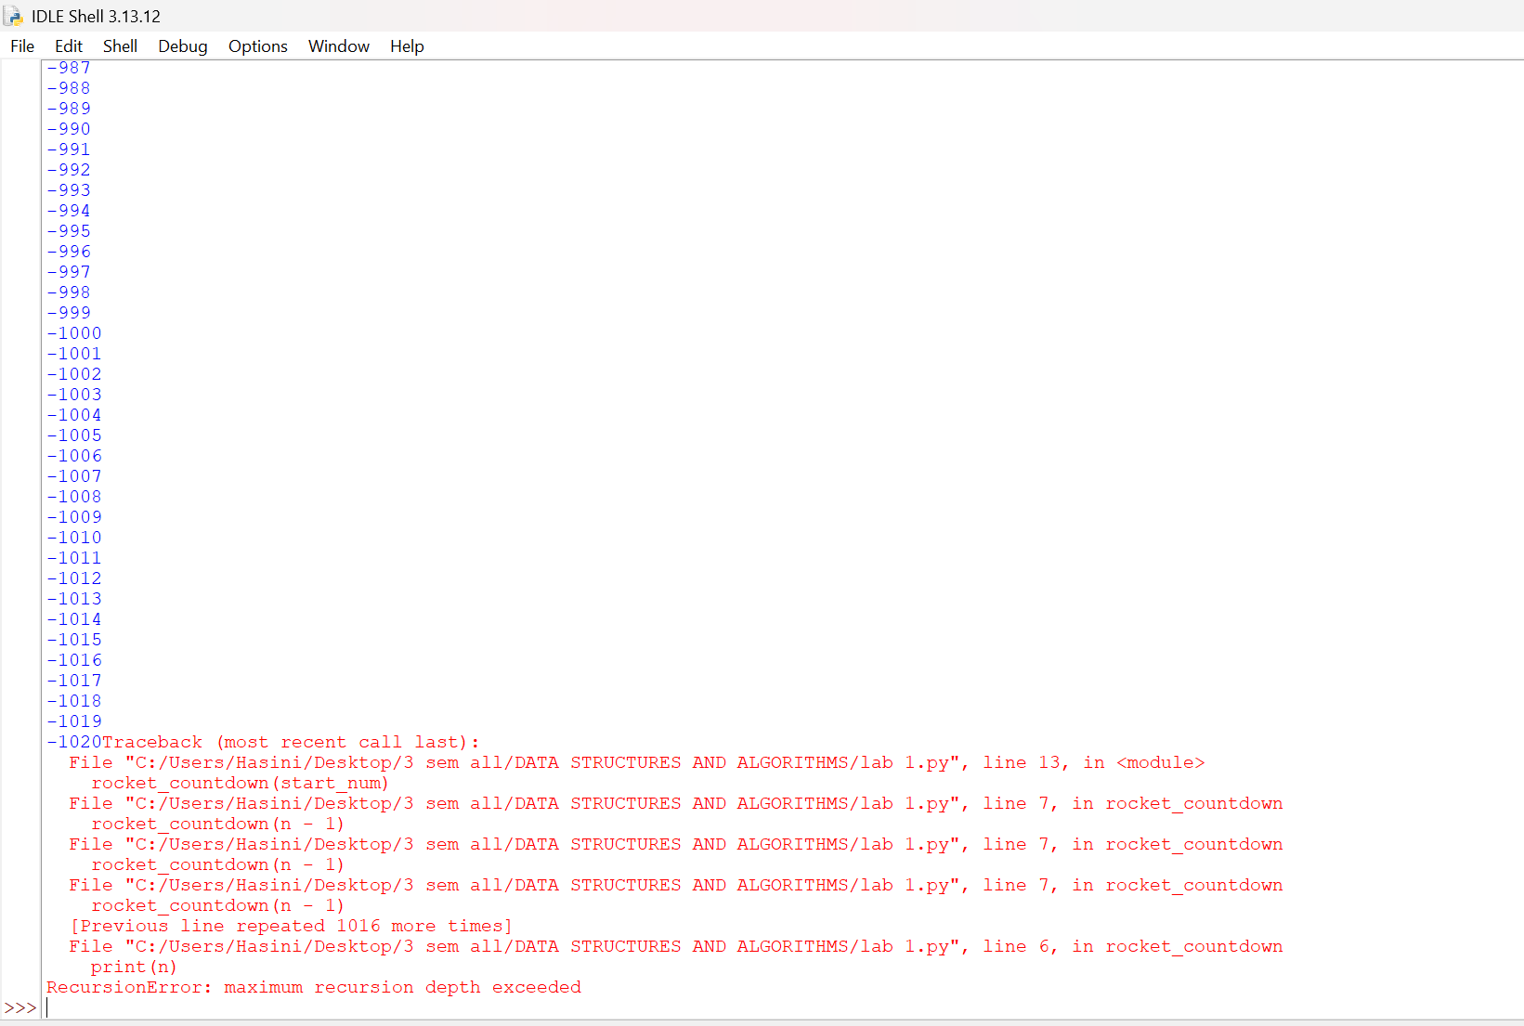

B.) Aim: Write a python program to calculate compound interest by taking user input.
Program:
def C_Int(p,n,r,t):
decimal_rate = r/100
total_amount = p*(1+decimal_rate/n)**(n*t)
interest_earned = total_amount - p
return total_amount, interest_earned
p = int(input("Enter the principal amount (₹) : "))
n = int(input("Times compounded per year : "))
r = float(input("Enter the annual interest rate (%) : "))
t = float(input("Enter the number of years : "))
final_balance, pure_interest = C_Int(p, n, r, t)
print("\n--- Financial Breakdown ---")
print(f"Interest Earned: ₹{pure_interest:.2f}")
print(f"Total Balance: ₹{final_balance:.2f}")

Output(+Ve Case):

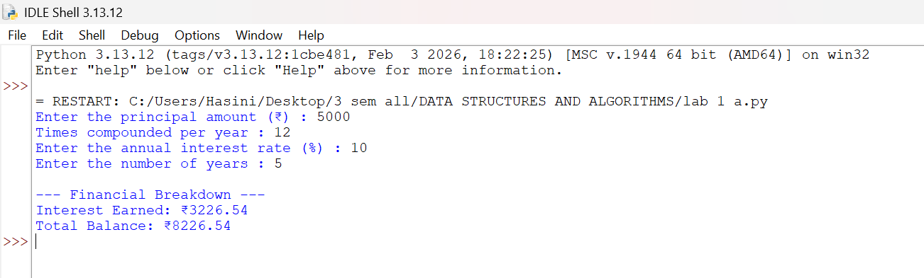

Output(-Ve Case):

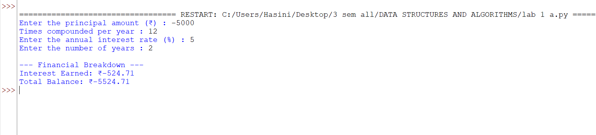

C.) Aim: HR Department stores Employee Id’s in a list develop a recursive program in python to search for a given employee Id in the list.
Program:
def rec_bin_search(arr,key,low,high):
if low > high :
return -1
mid = (low+high)//2

if arr[mid] == key:
return mid
elif key < arr[mid]:
return rec_bin_search(arr,key,low,mid-1)
else:
return rec_bin_search(arr,key,mid+1,high)

Emp_Ids = [1002, 1005, 1012, 1025, 1040, 1077, 1100]
search_id = int(input("Enter Employee ID to search: "))

result_index = rec_bin_search(Emp_Ids,search_id,0,(len(Emp_Ids)-1))
if result_index != -1:
print(f"Employee ID {search_id} found at index {result_index}.")
else:
print(f"Employee ID {search_id} not found in the HR system.")

Output(+Ve Case):

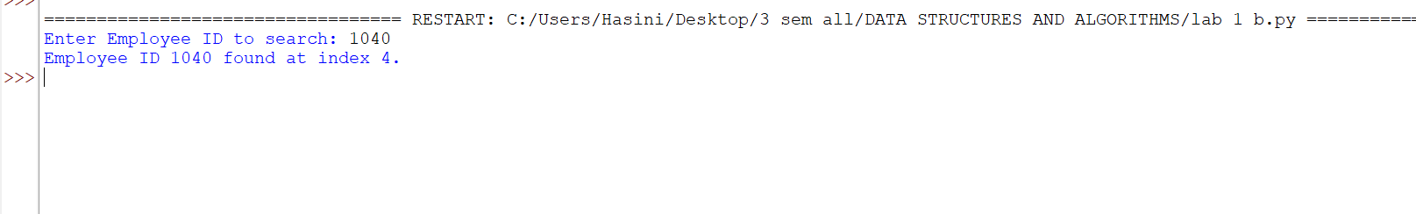

Output(-Ve Case):

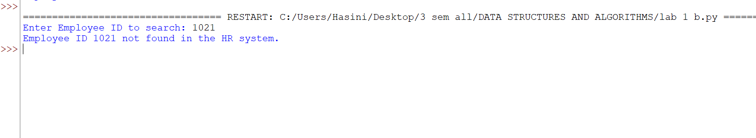

D.) Aim: Develop a python program to print 1st n terms of Fibonacci series.
Program:
def fib(n):
if(n < 0):
print("Please enter a +ve number")
return None
if (n == 0 or n == 1):
return n
else:
return fib(n-1)+fib(n-2)

n = int(input("Enter the number : "))
for i in range (n+1):
print(f"{fib(i)}",end = " ")
Output(+Ve Case):

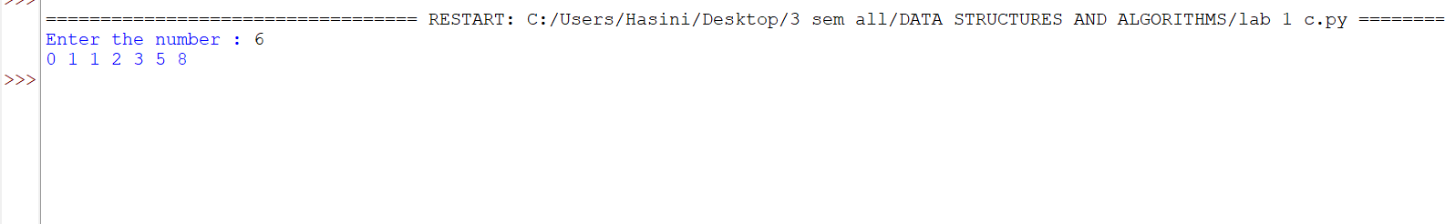

Output(-Ve Case):

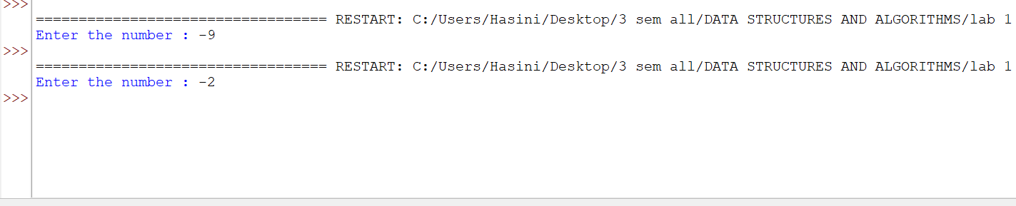

Explanation : a standard Fibonacci function should not accept negative numbers because negative inputs break the standard forward-sum logic and cause infinite loops.
E.) Aim: Develop a python program to calculate factorial of a given number.
Program:
def fac (n):
if n < 0 :
print("Please aenter a +ve number")
return None
if n == 0 or n == 1:
return 1
else:
return n*fac(n-1)
n = int(input("Enter a number : "))
print(f"The Factorial of {n} is {fac(n)}")
Output(+Ve Case):
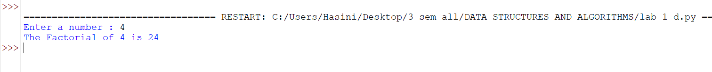

Output(-Ve Case):

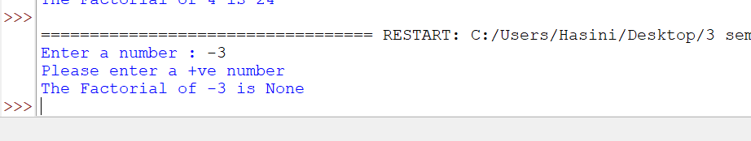

Explanation : The given Fibonacci sequence generator accepts only integer values giving values other than the integer data type such as float or special characters results in this type of Value Error.

LAB-2:
1.)Applying Searching Algorithms :
A.) Aim: Write a python program to implement linear search.
Program:
def lin_search(arr, key):
for i in range(len(arr)):
if arr[i] == key:
print(f"{key} at index {i}")
return
print(f"{key} not found")
n = int(input("Enter the number of elements: "))
arr = []
print("Enter elements:")
for i in range(n):
arr.append(int(input()))

key = int(input("Enter the key: "))
result = lin_search(arr, key)

Output(+Ve Case):

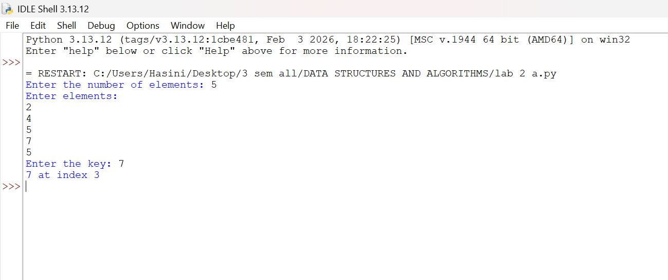

Output(-Ve Case):

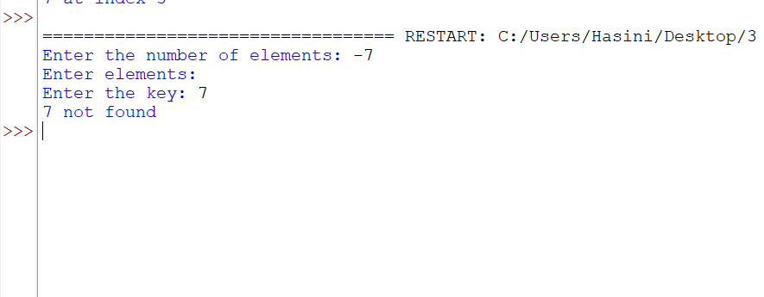

Explanation : The number of input elements should never be negative . In this case since input elements are -5 the program doesn’t allow me to enter any input elements nor is able to check the key given by the user.

B.) Aim: Write a python program to implement binary search with sorted array as input.
Program:
def bin_search(arr,key):
low = 0
high = len(arr) - 1
while low <= high:
mid = (high+low)//2
if arr[mid] == key:
return mid
elif arr[mid] < key:
low = mid+1
else:
high = mid-1
return -1

n = int(input("Enter the number of elements: "))

arr = []

print("Enter elements:")
for i in range(n):
arr.append(int(input()))

key = int(input("Enter the key: "))

result = bin_search(arr, key)
if result!=-1:
print(f"Element found at index {result}")
else:
print("Element not found")
Output(+Ve Case):

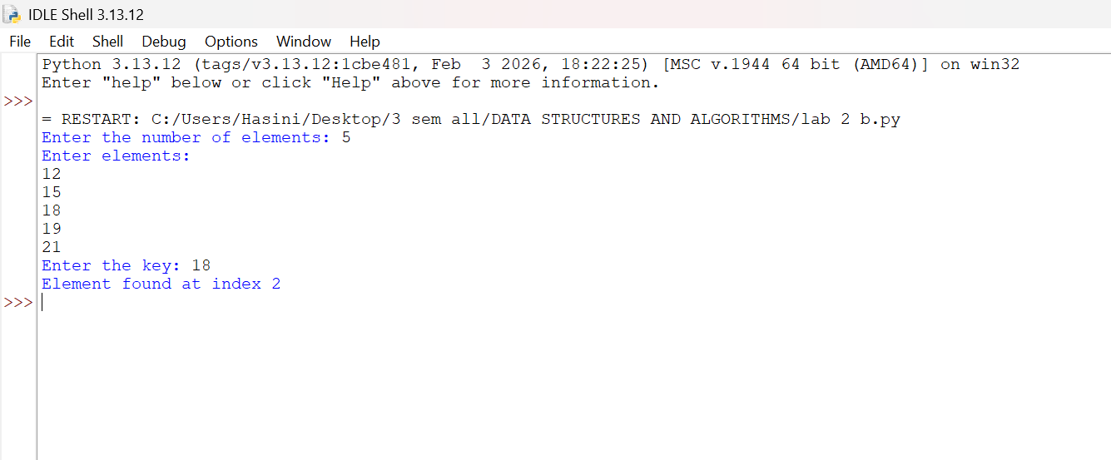

Output(-Ve Case):

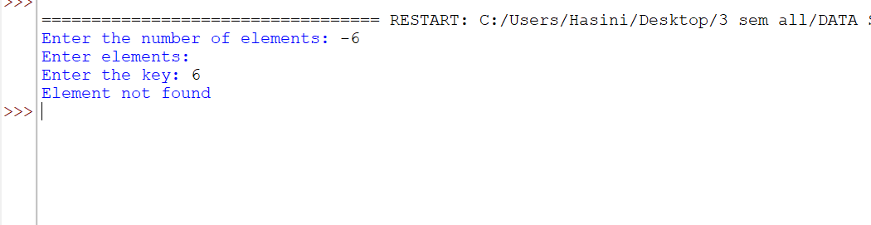

Explanation : The number of input elements should never be negative . In this case since input elements are -5 the program doesn’t allow me to enter any input elements nor is able to check the key given by the user.

(C) Aim: Write a python program to implement binary search with unsorted array as input.
Program:
def bin_search(arr,key):
low = 0
high = len(arr) - 1
while low <= high:
mid = (high+low)//2
if arr[mid] == key:
return mid
elif arr[mid] < key:
low = mid+1
else:
high = mid-1
return -1

n = int(input("Enter the number of elements: "))

arr = []

print("Enter elements:")
for i in range(n):
arr.append(int(input()))
if arr == sorted(arr):
print("\n input list is already sorted")
else:
print("input list is not sorted")
print("sorting list....")
arr.sort()
print(f"Sorted List : {arr}")

key = int(input("Enter the key: "))
result = bin_search(arr, key)
if result!=-1:
print(f"Element found at index {result}")
else:
print("Element not found")
Output

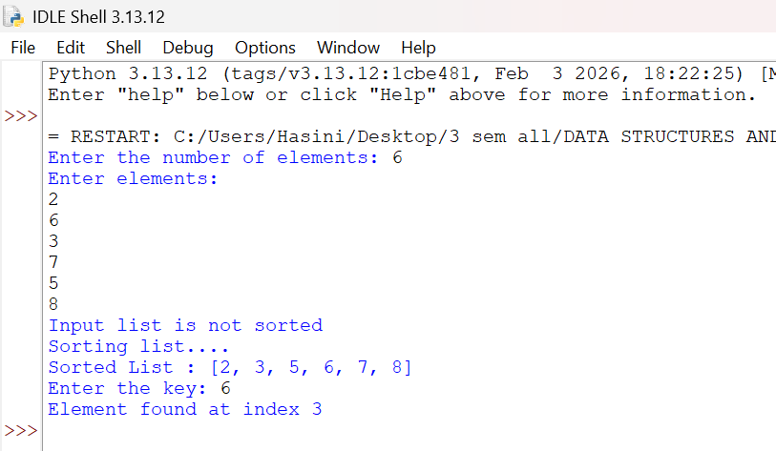

LAB-3:
A.) Aim: Write a python program to apply bubble sort where input elements are taken from the user .
Program:
def bubble_sort(arr):
n = len(arr)
for i in range(n-1):
for j in range(n-i-1):
if arr[j] > arr[j+1]:
arr[j],arr[j+1] = arr[j+1],arr[j]
return arr
n = int(input("Enter the number of elements: "))
arr = []
print("Enter elements:")
for i in range(n):
arr.append(int(input()))
result = bubble_sort(arr)
print(f"Sorted array : {result}")

Output
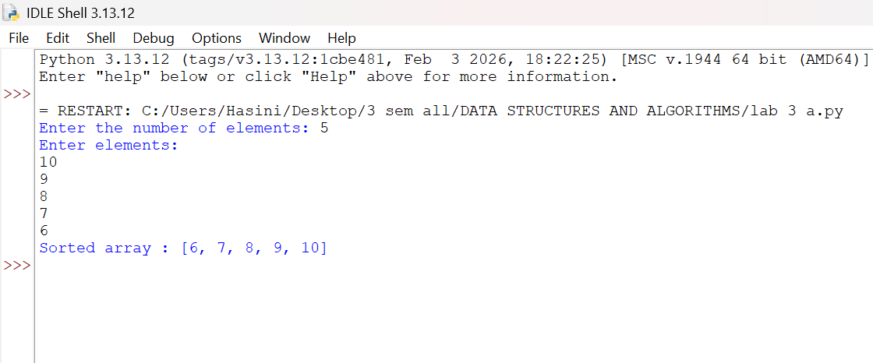

B.) Aim: Write a python program to apply insertion sort where input elements are taken from the user .
Program:
def insertion_sort(arr):
n = len(arr)
for i in range(1,n):
key = arr[i]
j = i-1
while j >= 0 and arr[j] > key:
arr[j+1] = arr[j]
j = j-1
arr[j+1] = key
return arr
n = int(input("Enter the number of elements: "))
arr = []
print("Enter elements:")
for i in range(n):
arr.append(int(input()))
result = insertion_sort(arr)
print(f"Sorted array : {result}")
Output

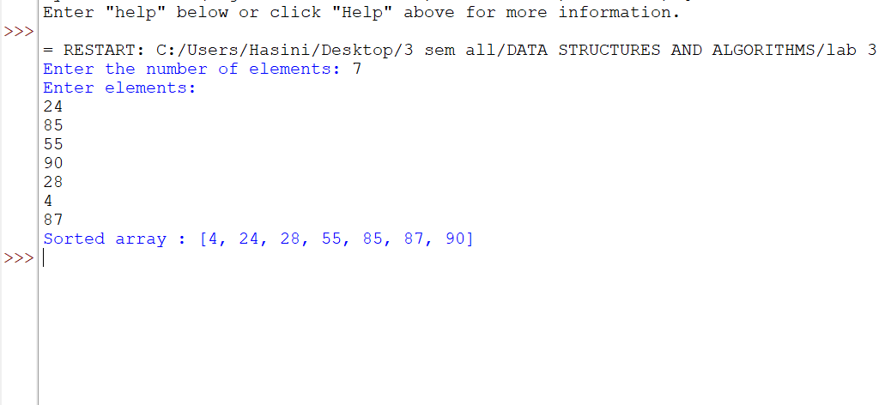

C.) Aim: Write a python program to apply selection sort where input elements are taken from the user .
Program:
def selection_sort(arr):
n = len(arr)
for i in range(n-1):
min_index = i
for j in range (i+1,n):
if arr[j] < arr[min_index]:
min_index = j
arr[i],arr[min_index] = arr[min_index],arr[i]
return arr
n = int(input("Enter the number of elements: "))
arr = []
print("Enter elements:")
for i in range(n):
arr.append(int(input()))
result = selection_sort(arr)
print(f"Sorted array : {result}")

Output:

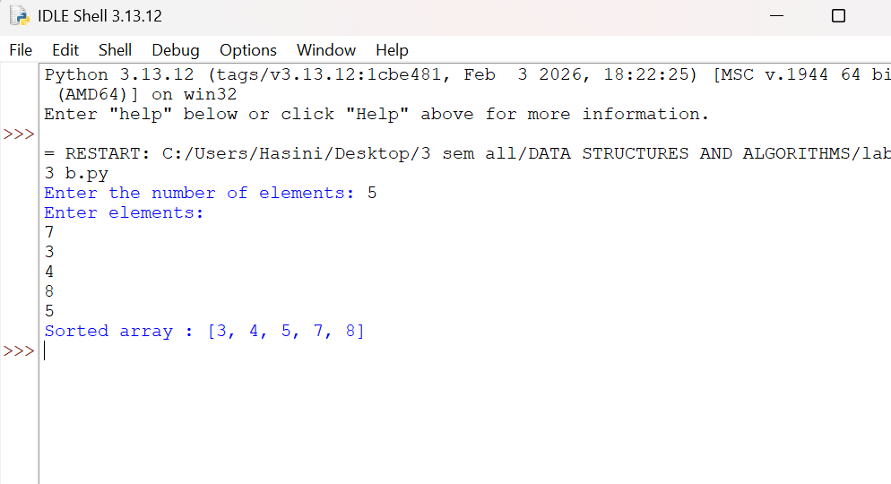

LAB-4:
A.) Aim: write a python program to implement quick sort, where the elements are taken from user.
Program:
def quicksort(a,low,high):
if low < high:
i = low
j = high
pivot = low
while i < j:
while i < len(a) and a[i] <= a[pivot]:
i+=1
while a[j] > a[pivot]:
j-=1
if i < j:
a[i],a[j] = a[j],a[i]
a[j],a[pivot] = a[pivot],a[j]
quicksort(a,low,j-1)#Left Part
quicksort(a,j+1,high)#Right Part

#Entering the Elements
n = int(input("Enter the number of elements: "))
a = []
print("Enter elements:")
for i in range(n):
a.append(int(input()))
quicksort(a, 0, n - 1)
print("Sorted Array :.......")
print(a)

Output:
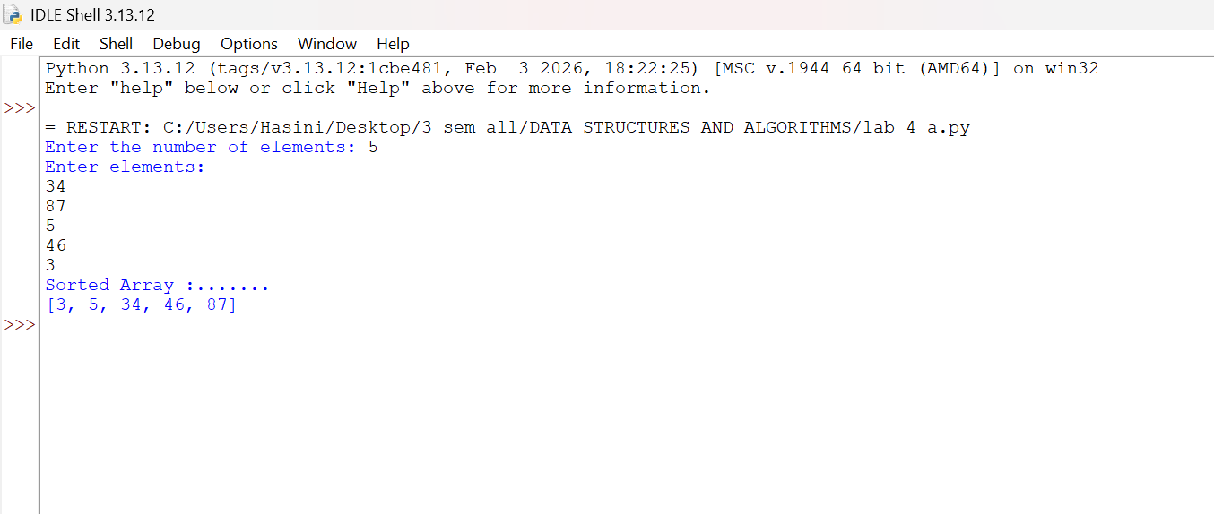

B.) Aim: write a python program to implement merge sort, where the elements are taken from user.
Program:
def merge_sort(arr):
# Base Condition
if len(arr) <= 1:
return arr
# Divide Array
mid = len(arr) // 2
left = arr[:mid]
right = arr[mid:]
# Recursive calls
merge_sort(left)
merge_sort(right)
# Merge sorted halves
i = j = k = 0
while i < len(left) and j < len(right):
if left[i] <= right[j]:
arr[k] = left[i]
i += 1
else:
arr[k] = right[j]
j += 1
k += 1
# Copy remaining elements from Left Array
while i < len(left):
arr[k] = left[i]
i += 1
k += 1
# Copy remaining elements from Right Array
while j < len(right):
arr[k] = right[j]
j += 1
k += 1
return arr
n = int(input("Enter the number of elements: "))
arr = []
print("Enter elements:")
for i in range(n):
arr.append(int(input()))
print("Sorted Array :.......")
print(merge_sort(arr))

Output:

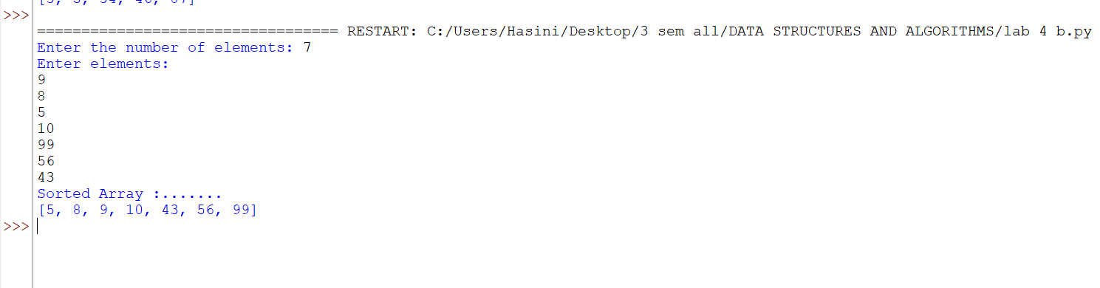
LAB-5:
Aim: A) Write a python program to implement a circular linked list with the below operations: A.create linked list B.insert at beginning C.Insert at end D.Insert at index E.Delete by value F.Delete first node G.Delete last node H.Count number of nodes I.Display/traverse J.exit
Program:
class Node:
#[cite: 12]
def __init__(self, data):
self.data = data
self.next = None
class CircularLinkedList:
#[cite: 12]
def __init__(self):
self.head = None
self.tail = None
# Insert at Beginning[cite: 13]
def insert_begin(self, data):
new = Node(data)
# Case 1: Empty list
if self.head is None:
self.head = new
self.tail = new
new.next = self.head
# Case 2: Non-empty list
else:
new.next = self.head
self.head = new
self.tail.next = self.head
# Insert at End[cite: 14]
def insert_end(self, data):
new = Node(data)
# Case 1: Empty list
if self.head is None:
self.head = new
self.tail = new
new.next = self.head
# Case 2: Non-empty list
else:
new.next = self.head
self.tail.next = new
self.tail = new
# Insert at Particular Position[cite: 15]
# Position starts from 0
def insert_position(self, position, data):
# Insert at beginning
if position == 0:
self.insert_begin(data)
return
if self.head is None or position < 0:
print("Invalid position")
return
new = Node(data)
temp = self.head
# Move to the node before the required position[cite: 16]
for i in range(position - 1):
temp = temp.next
# We have completed one circle
if temp == self.head:
print("Invalid position")
return
# Insert new node
new.next = temp.next
temp.next = new
# If inserted after tail, update tail
if temp == self.tail:
self.tail = new
# Delete at Beginning[cite: 17]
def delete_begin(self):
if self.head is None:
print("List is empty")
return
# Only one node
if self.head == self.tail:
self.head = None
self.tail = None
# More than one node
else:
self.head = self.head.next
self.tail.next = self.head
# Delete at End[cite: 18]
def delete_end(self):
if self.head is None:
print("List is empty")
return
# Only one node
if self.head == self.tail:
self.head = None
self.tail = None
return
# Find node before tail
temp = self.head
while temp.next != self.tail:
temp = temp.next
temp.next = self.head
self.tail = temp
# Traverse the Circular Linked List[cite: 19]
def traverse(self):
if self.head is None:
print("List is empty")
return
temp = self.head
while True:
print(temp.data, end=" -> ")
temp = temp.next
if temp == self.head:
break
print("(back to head)")

# Display Head and Tail[cite: 20]
def display_head_tail(self):
if self.head is None:
print("List is empty")
else:
print("Head =", self.head.data)
print("Tail =", self.tail.data)
print("Tail.next =", self.tail.next.data)
# Menu-driven implementation
if __name__ == "__main__":
cll = CircularLinkedList()
while True:
print("\n--- Circular Linked List Menu ---")
print("1. Insert at Beginning")
print("2. Insert at End")
print("3. Insert at Position")
print("4. Delete at Beginning")
print("5. Delete at End")
print("6. Traverse List")
print("7. Display Head and Tail")
print("8. Exit")
ch = int(input("Enter your choice: "))
if ch == 1:
x = int(input("Value: "))
cll.insert_begin(x)
elif ch == 2:
x = int(input("Value: "))
cll.insert_end(x)
elif ch == 3:
pos = int(input("Position (starts from 0): "))
x = int(input("Value: "))
cll.insert_position(pos, x)
elif ch == 4:
cll.delete_begin()
elif ch == 5:
cll.delete_end()
elif ch == 6:
cll.traverse()
elif ch == 7:
cll.display_head_tail()
elif ch == 8:
print("Exiting...")
break
else:
print("Invalid choice, please try again." )

Output:
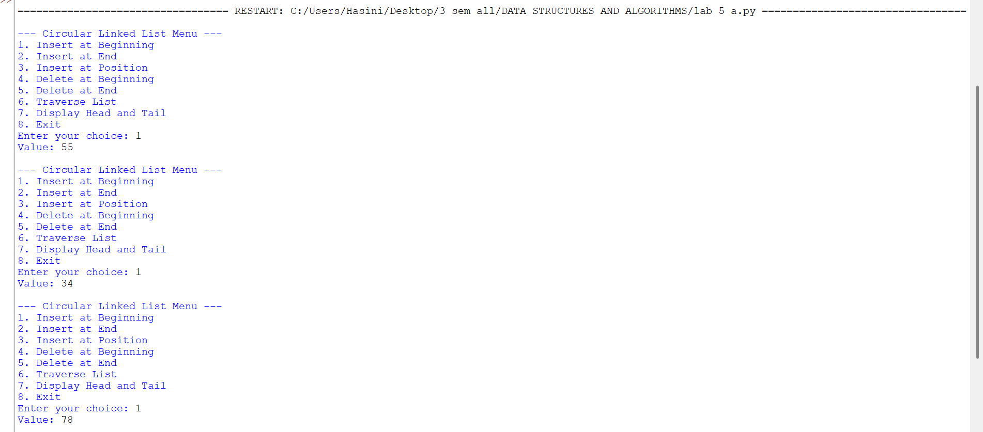

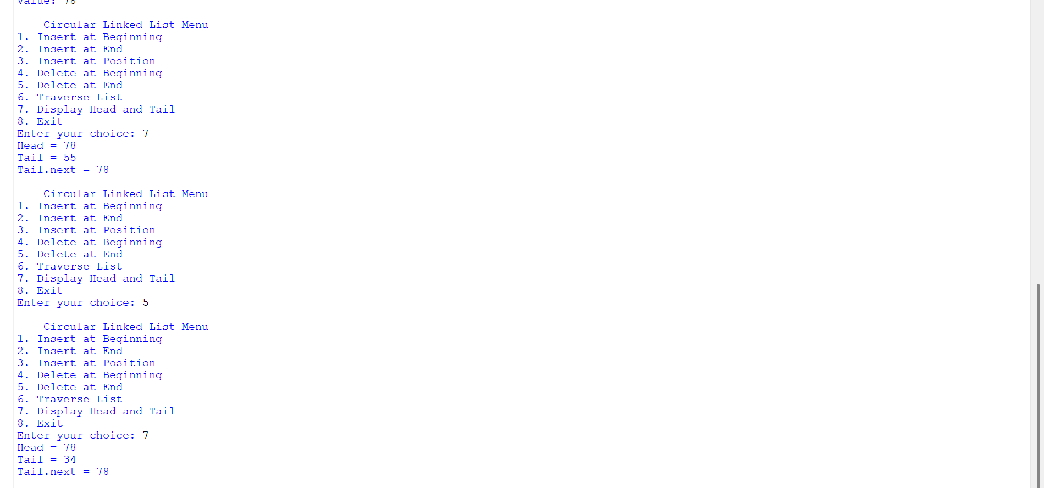
B.) Aim: Write a python program to implement a single linked list with the below operations: A.create linked list B.insert at beginning C.Insert at end D.Insert at index E.Delete by value F.Delete first node G.Delete last node H.Count number of nodes I.Display/traverse J.exit
Program:
class Node:
def __init__(self, data):
self.data = data
self.next = None
class SinglyLinkedList:
def __init__(self):
self.head = None
def create(self):
n = int(input(("Enter number of elements:")))
for i in range(n):
x = int(input(("Enter value:")))
new = Node(x)
if self.head is None:
self.head = new
else:
temp = self.head
while temp.next:
temp = temp.next
temp.next = new
def insert_begin(self, data):
new = Node(data)
new.next = self.head
self.head = new
def insert_end(self, data):
new = Node(data)
if self.head is None:
self.head = new
else:
temp = self.head
while temp.next:
temp = temp.next
temp.next = new
def insert_index(self, index, data):
if index == 0:
self.insert_begin(data)
return
elif index > self.count() or index < 0:
print("Invalid Index")
return
new = Node(data)
temp = self.head
for i in range(index - 1):
temp = temp.next
new.next = temp.next
temp.next = new
def deleteAtBeg(self):
if self.head is None:
print("No Data to delete")
else:
temp = self.head
self.head = temp.next
print("Deleted Value = ",temp.data)
def deleteAtEnd(self):
if self.head is None:
print("No Data to delete")
elif self.head.next is None:
self.head = None
else:
temp = self.head
temp1 = temp
while temp.next:
temp1 = temp
temp = temp.next
temp1.next = None
def delete(self, value):
if self.head is None:
print("No Data to delete")
else:
temp = self.head
if temp and temp.data == value:
self.head = temp.next
print("Value deleted")
return
while temp.next and temp.next.data != value:
temp = temp.next
if temp.next is None:
print("Value not present")
else:
temp.next = temp.next.next
print("Value deleted")
def display(self):
if self.head is None:
print("No Data")
else:
temp = self.head
while temp:
print(temp.data, end=" -> ")
temp = temp.next
print("None")
def count(self):
if self.head is None:
print("No Linked List")
return 0
else:
c = 0
temp = self.head
while temp:
c += 1
temp = temp.next
print(f"Number of nodes = {c}")
return c
# Menu-driven implementation matching the provided snippet
if __name__ == "__main__":
sll = SinglyLinkedList()
while True:
print("\n1. Create\n2. Insert at Beginning\n3. Insert at End\n4. Insert at Index\n5. Delete Value\n6. Delete at Beginning\n7. Delete at End\n8. Count\n9. Display\n10. Exit")
ch = int(input("Enter choice: "))
if ch == 1:
sll.create()
elif ch == 2:
x = int(input("Value: "))
sll.insert_begin(x)
elif ch == 3:
x = int(input("Value: "))
sll.insert_end(x) elif ch == 4:
idx = int(input("Index: "))
x = int(input("Value: "))
sll.insert_index(idx, x)
elif ch == 5:
x = int(input("Delete value: "))
sll.delete(x)
elif ch == 6:
sll.deleteAtBeg()
elif ch == 7:
sll.deleteAtEnd()
elif ch == 8:
sll.count()
elif ch == 9:
sll.display()
elif ch == 10:
break
Output:

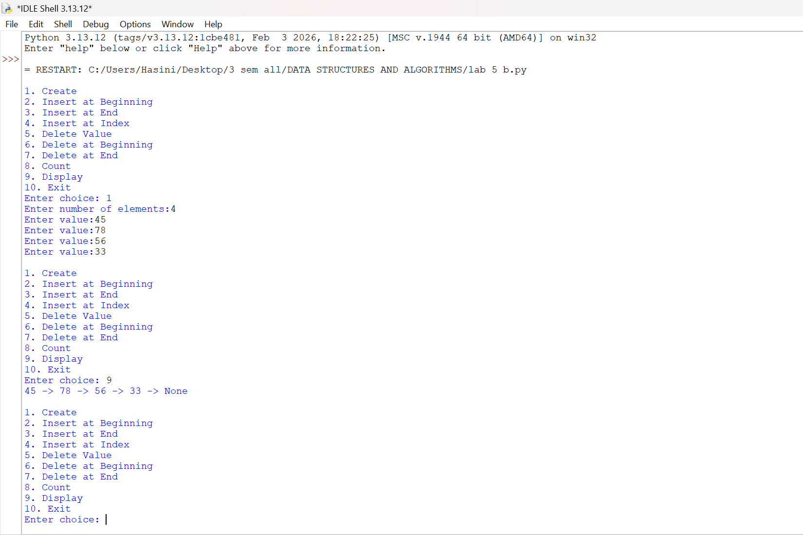

LAB-6:
A ) Aim: Write a python program to implement stack operations such as push, pop, peek, display using linked list.
Program:
class Node:
def __init__(self, data):
self.data = data
self.next = None
class Stack:
def __init__(self):
self.top = None
def push(self, data):
new = Node(data)
new.next = self.top
self.top = new
print(data, "pushed into stack")
def pop(self):
if self.top is None:
print("Stack Underflow")
else:
print(self.top.data, "popped from stack")
self.top = self.top.next
def peek(self):
if self.top is None:
print("Stack is empty")
else:
print("Top element:", self.top.data)
def display(self):
if self.top is None:
print("Stack is empty")
else:
temp = self.top
print("Stack elements:")
while temp is not None:
print(temp.data)
temp = temp.next
s = Stack()
while True:
print("\n--- STACK USING LINKED LIST ---")
print("1. Push")
print("2. Pop")
print("3. Peek")
print("4. Display")
print("5. Exit")
choice = int(input("Enter your choice: "))
if choice == 1:
data = int(input("Enter the element: "))
s.push(data)
elif choice == 2:
s.pop()
elif choice == 3:
s.peek()
elif choice == 4:
s.display()
elif choice == 5:
print("Program terminated")
break
else:
print("Invalid choice")

Output:
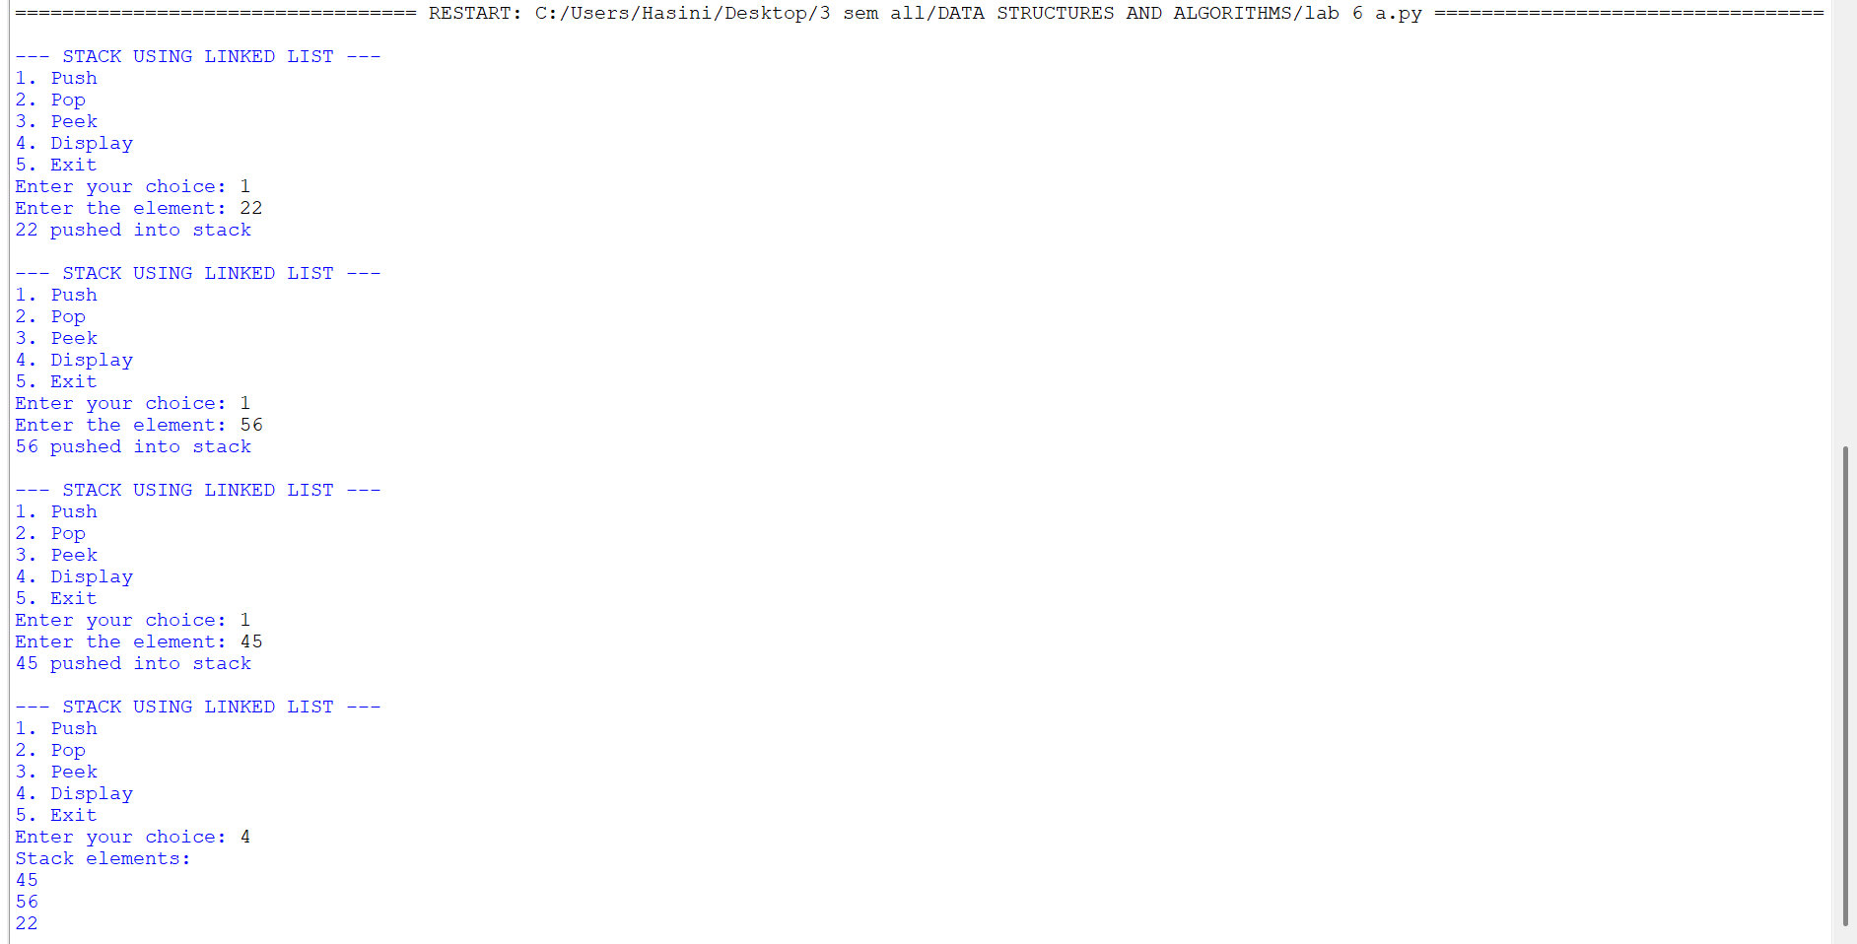

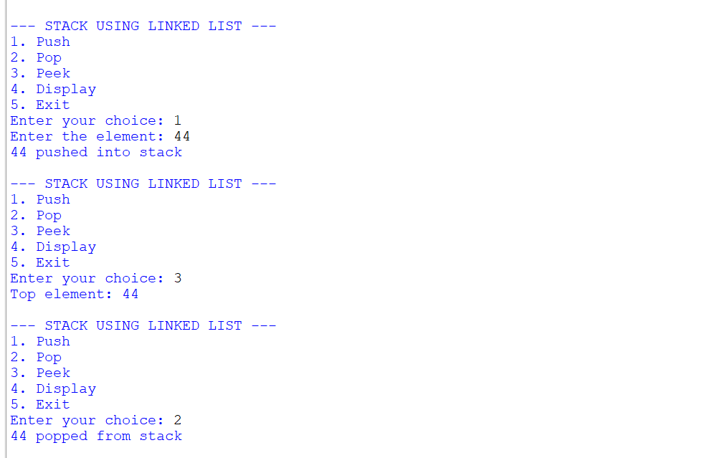

B ) Aim: Write a python program to implement stack operations such as push, pop, peek, display using an array.
Program:
class StackEx:
#
def __init__(self, size):
self.size = size
self.stack = [None] * size
self.top = -1

# Push operation
def push(self, item):
if self.top == self.size - 1:
print("Stack Overflow")
else:
self.top += 1
self.stack[self.top] = item
print(item, "pushed into the stack")

# Pop operation
def pop(self):
if self.top == -1:
print("Stack Underflow")
else:
item = self.stack[self.top]
self.stack[self.top] = None
self.top -= 1
print(item, "popped from the stack")

# Peek operation
def peek(self):
if self.top == -1:
print("Stack is empty")
else:
print("Top element:", self.stack[self.top])

# Display operation
def display(self):
if self.top == -1:
print("Stack is empty")
else:
print("The elements of the stack are:")
for i in range(self.top, -1, -1):
print(self.stack[i])

# Create stack
size = int(input("Enter the size of the stack: "))
s = StackEx(size)
while True:
print("\n----- STACK MENU USING AN ARRAY-----")
print("1. Push")
print("2. Pop")
print("3. Peek")
print("4. Display")
print("5. Exit")
choice = int(input("Enter your choice: "))
if choice == 1:
item = int(input("Enter the element to push: "))
s.push(item)
elif choice == 2:
s.pop()
elif choice == 3:
s.peek()
elif choice == 4:
s.display()
elif choice == 5:
print("Program terminated.")
break
else:
print("Invalid choice")

Output:
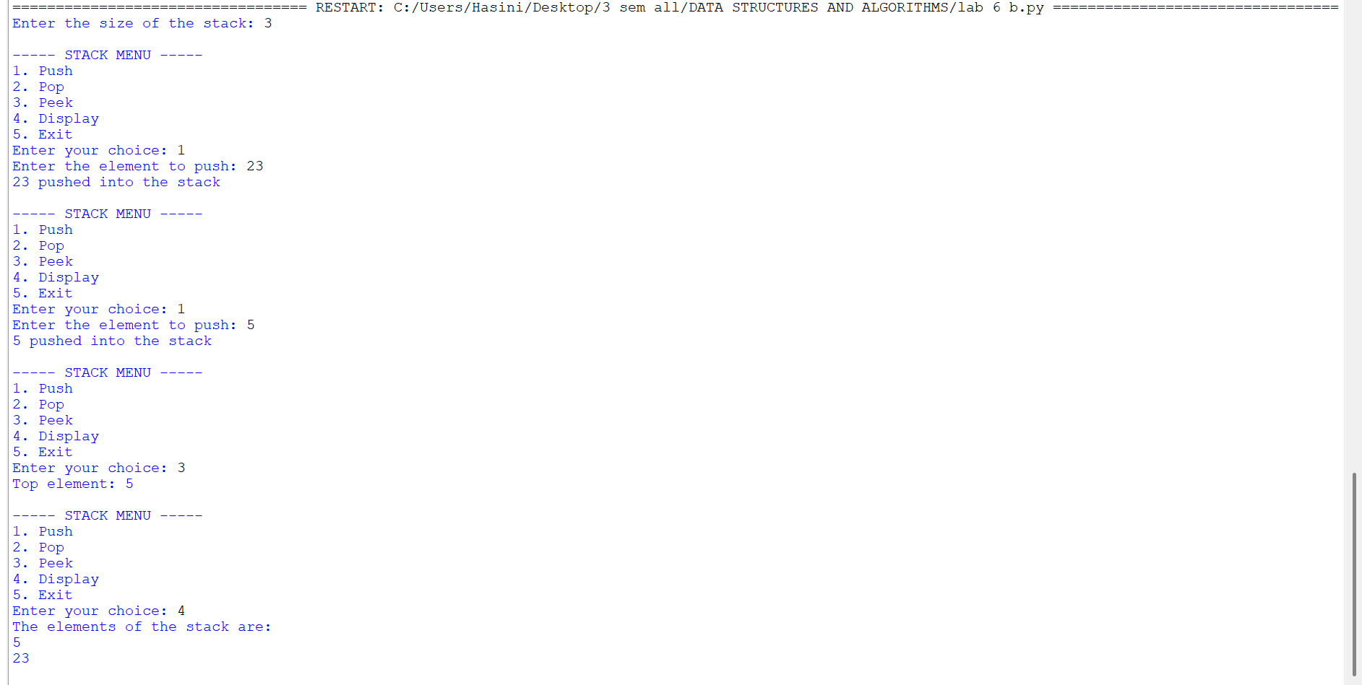
LAB-7:
A.) Aim: Write a python program to implement queue and its operations such as enqueue, dequeue, peek and display with a menu driven approach using an array
Program:
class Node:
def __init__(self, data):
self.data = data
self.next = None
class QueueEx:
def __init__(self):
self.front = None
self.rear = None
def enqueue(self, x):
new = Node(x)
if self.rear is None:
self.front = self.rear = new
else:
self.rear.next = new
self.rear = new
print(item, "inserted into the queue")
def dequeue(self):
if self.front is None:
print("Queue underflow")
else:
x = self.front.data
self.front = self.front.next
if self.front is None:
self.rear = None
print(f"{x} deleted from the queue")

def peek(self):
if self.front is None:
print("Queue is empty")
else:
print("Front element:", self.front.data)
def display(self):
if self.front is None:
print("Queue is empty")
else:
temp = self.front
print("Queue elements are:")
while temp:
print(temp.data, end=" ")
temp = temp.next
print()
q = QueueEx()
while True:
print("\n----- QUEUE MENU -----")
print("1. Enqueue")
print("2. Dequeue")
print("3. Peek")
print("4. Display")
print("5. Exit")
choice = int(input("Enter your choice: "))
if choice == 1:
item = int(input("Enter the element to enqueue: "))
q.enqueue(item)
elif choice == 2:
q.dequeue()
elif choice == 3:
q.peek()
elif choice == 4:
q.display()
elif choice == 5:
print("Program terminated.")
break
else:
print("Invalid choice")

Output:

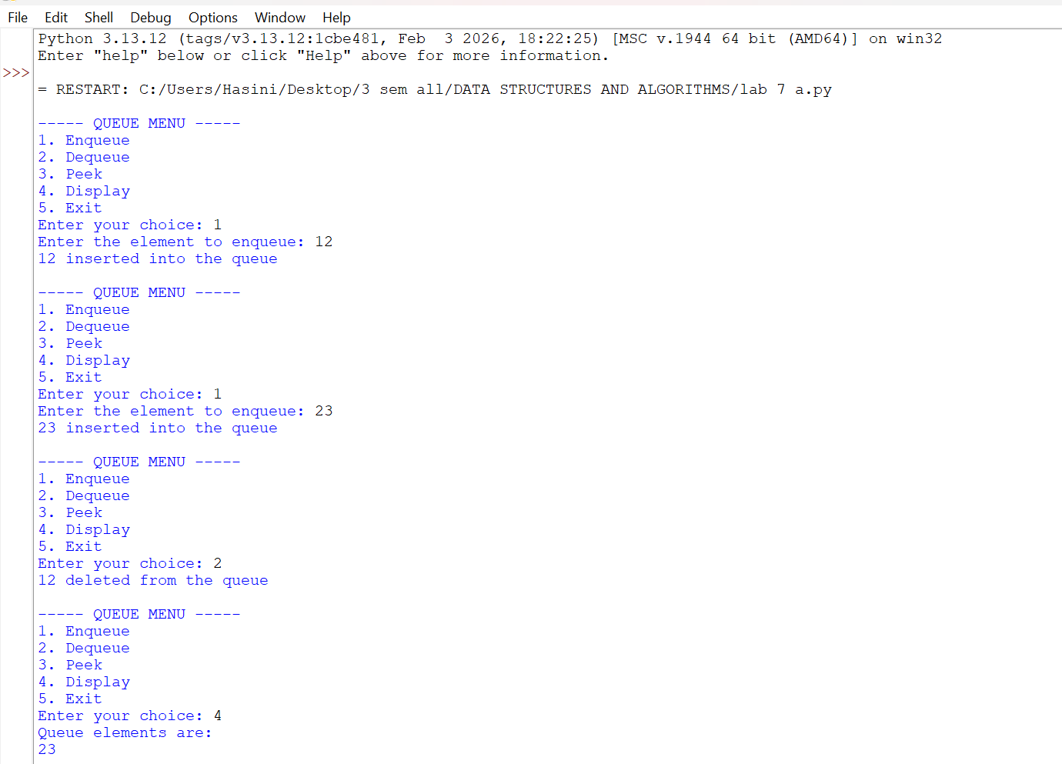
B.) Aim: Write a python program to implement queue and its operations such as enqueue, dequeue, peek and display with a menu driven approach using an linked list.
Program:
class Node:
def __init__(self, data):
self.data = data
self.next = None
class QueueEx:
def __init__(self):
self.front = None
self.rear = None
# Enqueue operation (Insert at the rear)
def enqueue(self, x):
new_node = Node(x)
# If the queue is empty, both front and rear point to the new node
if self.rear is None:
self.front = self.rear = new_node
else:
self.rear.next = new_node
self.rear = new_node
print(x, "inserted into the queue")
# Dequeue operation (Delete from the front)
def dequeue(self):
if self.front is None:
print("Queue Underflow")
else:
x = self.front.data
self.front = self.front.next
# If the queue becomes empty after deletion, update rear to None
if self.front is None:
self.rear = None
print(f"{x} deleted from the queue"
# Peek operation (View the front element)
def peek(self):
if self.front is None:
print("Queue is empty")
else:
print("Front element:", self.front.data)
# Display operation (Traverse from front to rear)
def display(self):
if self.front is None:
print("Queue is empty")
else:
temp = self.front
print("Queue elements are:")
while temp:
print(temp.data, end=" ")
temp = temp.next
print() # For a new line
# Main Program Loop
q = QueueEx()
while True:
print("\n----- QUEUE USING SL MENU -----")
print("1. Enqueue")
print("2. Dequeue")
print("3. Peek")
print("4. Display")
print("5. Exit")
try:
choice = int(input("Enter your choice: "))
if choice == 1:
item = int(input("Enter the element to enqueue: "))
q.enqueue(item)
elif choice == 2:
q.dequeue()
elif choice == 3:
q.peek()
elif choice == 4:
q.display()
elif choice == 5:
print("Program terminated.")
break
else:
print("Invalid choice. Please choose between 1 and 5.")
except ValueError:
print("Please enter a valid integer number.")
Output:

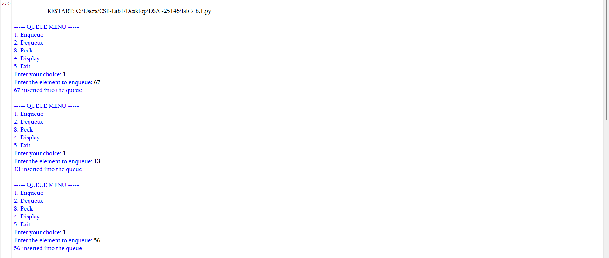

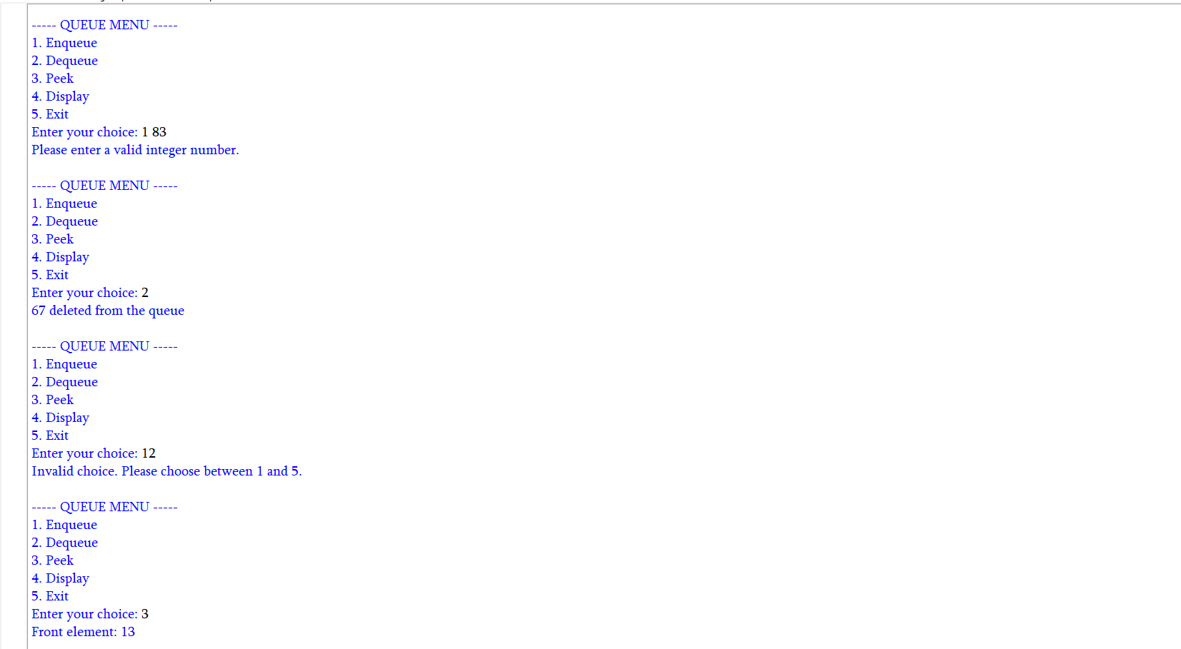
- ) Aim: Write a python program to implement circular queue and its operations such as enqueue, dequeue, peek and display with a menu driven approach using an array.

Program:
class CircularQueueEx:
def __init__(self, size):
self.size = size
self.queue = [None] * size
self.front = -1
self.rear = -1
# Enqueue operation (Insert element)
def enqueue(self, item):
# Condition for Queue Overflow
if (self.rear + 1) % self.size == self.front:
print("Queue Overflow")
else:
# If inserting the first element
if self.front == -1:
self.front = 0
# Circularly increment rear index
self.rear = (self.rear + 1) % self.size
self.queue[self.rear] = item
print(item, "inserted into the circular queue")
# Dequeue operation (Delete element)
def dequeue(self):
# Condition for Queue Underflow
if self.front == -1:
print("Queue Underflow")
else:
item = self.queue[self.front]
self.queue[self.front] = None # Clear the slot

# If the queue has only one element, reset pointers after deletion
if self.front == self.rear:
self.front = -1
self.rear = -1
else:
# Circularly increment front index
self.front = (self.front + 1) % self.size
print(f"{item} deleted from the circular queue")
# Peek operation (View the front element)
def peek(self):
if self.front == -1:
print("Queue is empty")
else:
print("Front element:", self.queue[self.front])
# Display operation
def display(self):
if self.front == -1:
print("Queue is empty")
else:
print("The elements of the circular queue are:")
i = self.front
while True:
print(self.queue[i], end=" ")
if i == self.rear:
break
i = (i + 1) % self.size
print() # For a new line
# Main Program Loop
size = int(input("Enter the size of the circular queue: "))
cq = CircularQueueEx(size)
while True:
print("\n----- CIRCULAR QUEUE USING ARRAY MENU -----")
print("1. Enqueue")
print("2. Dequeue")
print("3. Peek")
print("4. Display")
print("5. Exit")
try:
choice = int(input("Enter your choice: "))
if choice == 1:
item = int(input("Enter the element to enqueue: "))
cq.enqueue(item)
elif choice == 2:
cq.dequeue()
elif choice == 3:
cq.peek()
elif choice == 4:
cq.display()
elif choice == 5:
print("Program terminated.")
break
else:
print("Invalid choice. Please choose between 1 and 5.")
except ValueError:
print("Please enter a valid integer number."

Output:

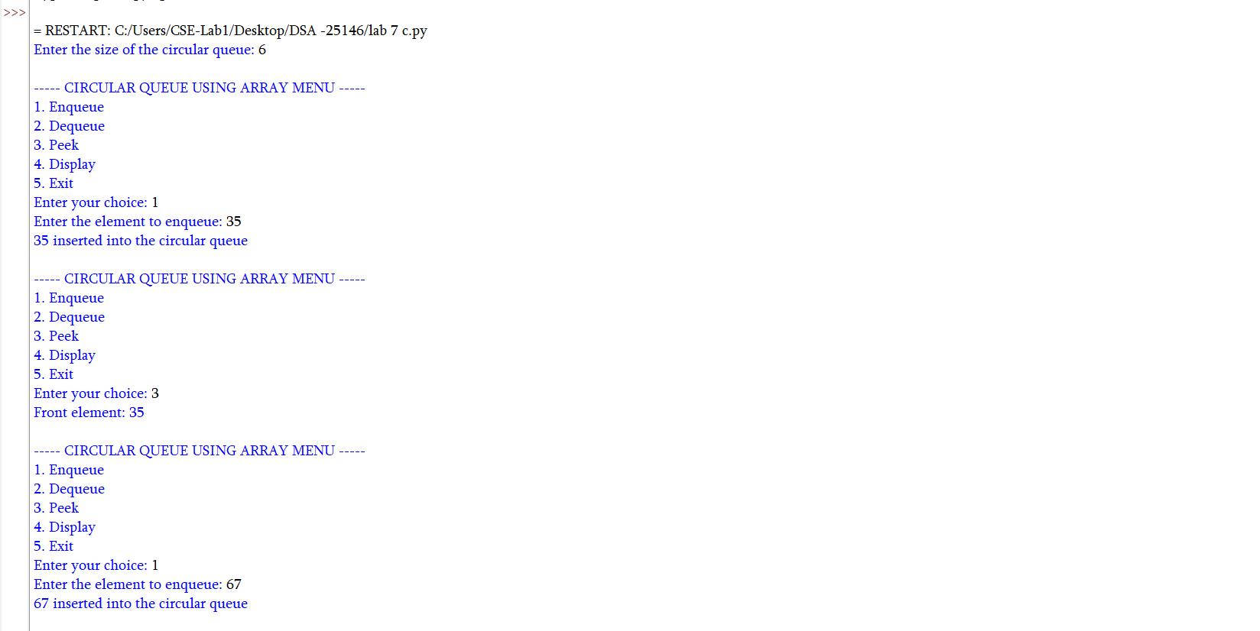

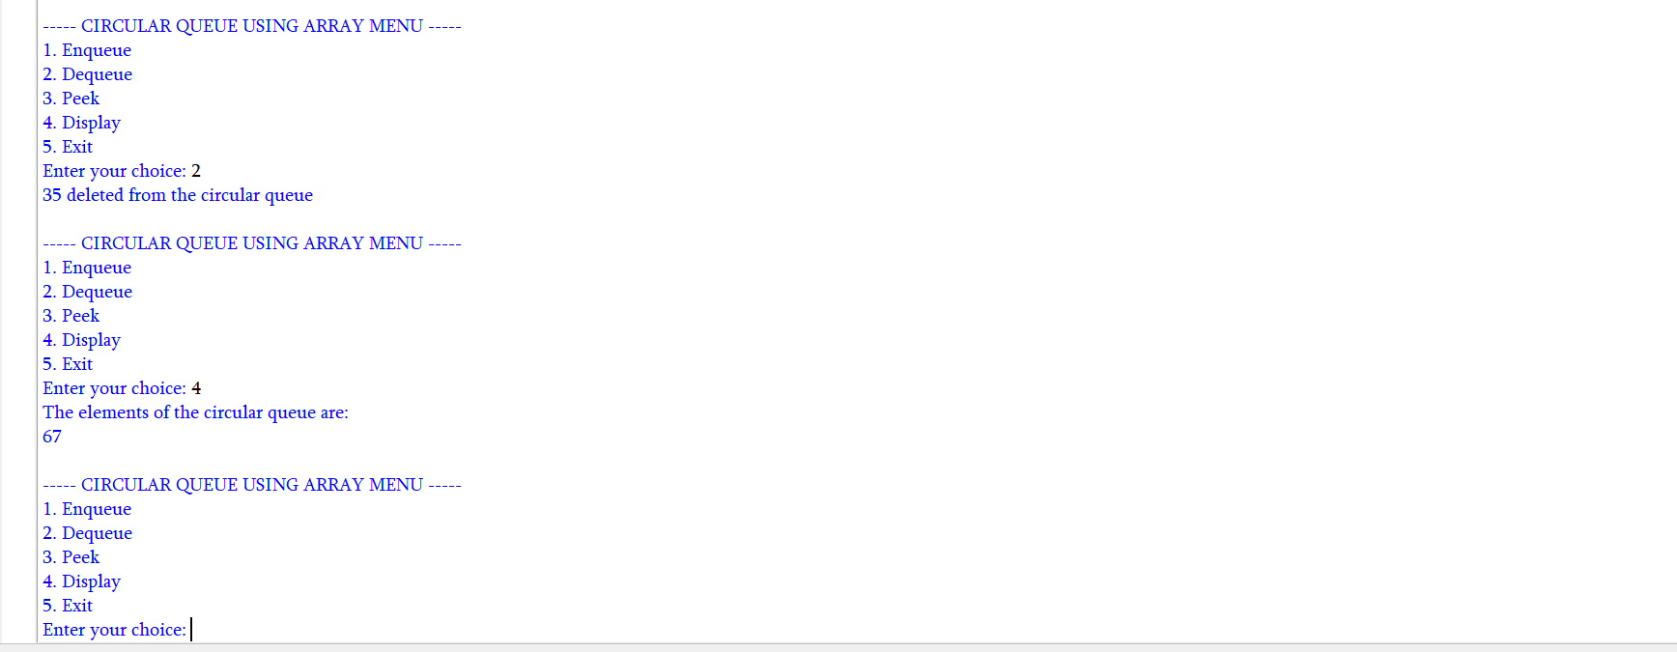

- ) Aim: Write a python program to implement circular queue and its operations such as enqueue, dequeue, peek and display with a menu driven approach using an linked list.
Program:
class Node:
def __init__(self, data):
self.data = data
self.next = None
class CircularQueueLinkedList:
def __init__(self):
self.rear = None
# Enqueue operation (Insert element at the end)
def enqueue(self, item):
new_node = Node(item)
# If the queue is empty
if self.rear is None:
self.rear = new_node
self.rear.next = self.rear # Point to itself to maintain circularity
else:
# New node points to the front node
new_node.next = self.rear.next
# Current rear node points to the new node
self.rear.next = new_node
# Move the rear pointer to the new node
self.rear = new_node
print(item, "inserted into the circular queue")
# Dequeue operation (Delete element from the front)
def dequeue(self):
# Condition for Underflow
if self.rear is None:
print("Queue Underflow")
else:
front = self.rear.next
item = front.data
# If the queue has only one node
if self.rear == front:
self.rear = None
else:
# Rear bypasses the old front to point to the next node
self.rear.next = front.next
print(f"{item} deleted from the circular queue")
# Peek operation (View the front element)
def peek(self):
if self.rear is None:
print("Queue is empty")
else:
front = self.rear.next
print("Front element:", front.data)
# Display operation
def display(self):
if self.rear is None:
print("Queue is empty")
else:
print("The elements of the circular queue are:")
front = self.rear.next
temp = front
while True:
print(temp.data, end=" ")
temp = temp.next
# Stop when we loop back to the front node
if temp == front:
break
print() # For a new line
# Main Program Loop
cq = CircularQueueLinkedList()
while True:
print("\n----- CIRCULAR QUEUE (LINKED LIST) MENU -----")
print("1. Enqueue")
print("2. Dequeue")
print("3. Peek")
print("4. Display")
print("5. Exit")
try:
choice = int(input("Enter your choice: "))
if choice == 1:
item = int(input("Enter the element to enqueue: "))
cq.enqueue(item)
elif choice == 2:
cq.dequeue()
elif choice == 3:
cq.peek()
elif choice == 4:
cq.display()
elif choice == 5:
print("Program terminated.")
break
else:
print("Invalid choice. Please choose between 1 and 5.")
except ValueError:
print("Please enter a valid integer number.")

Output:
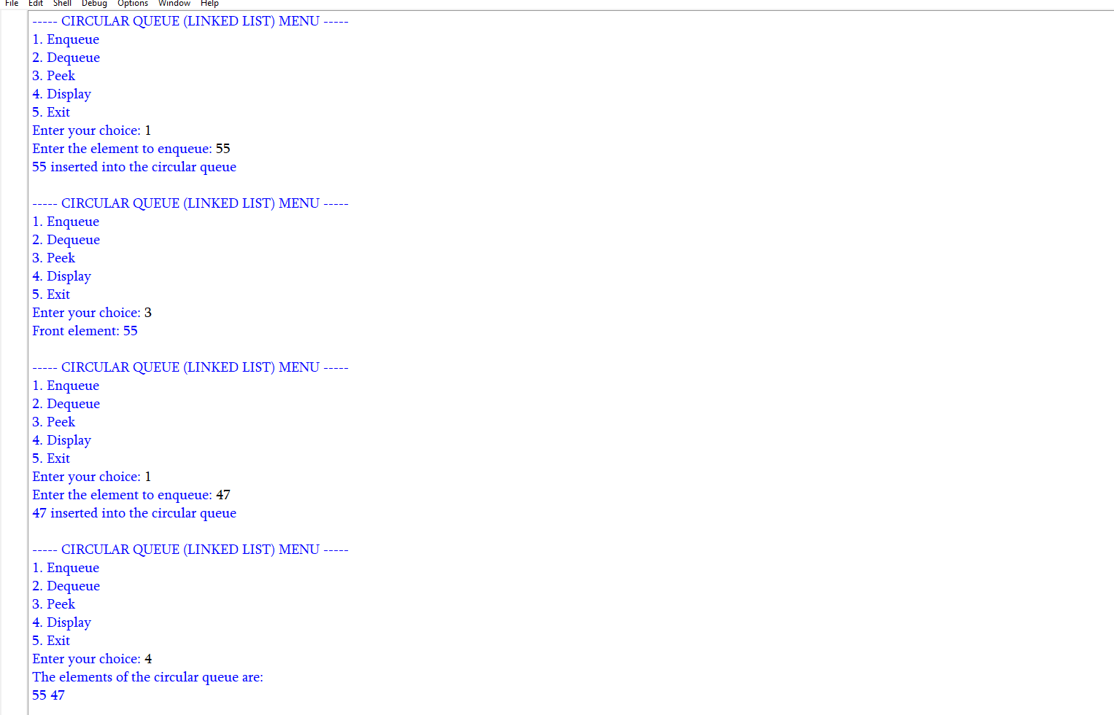

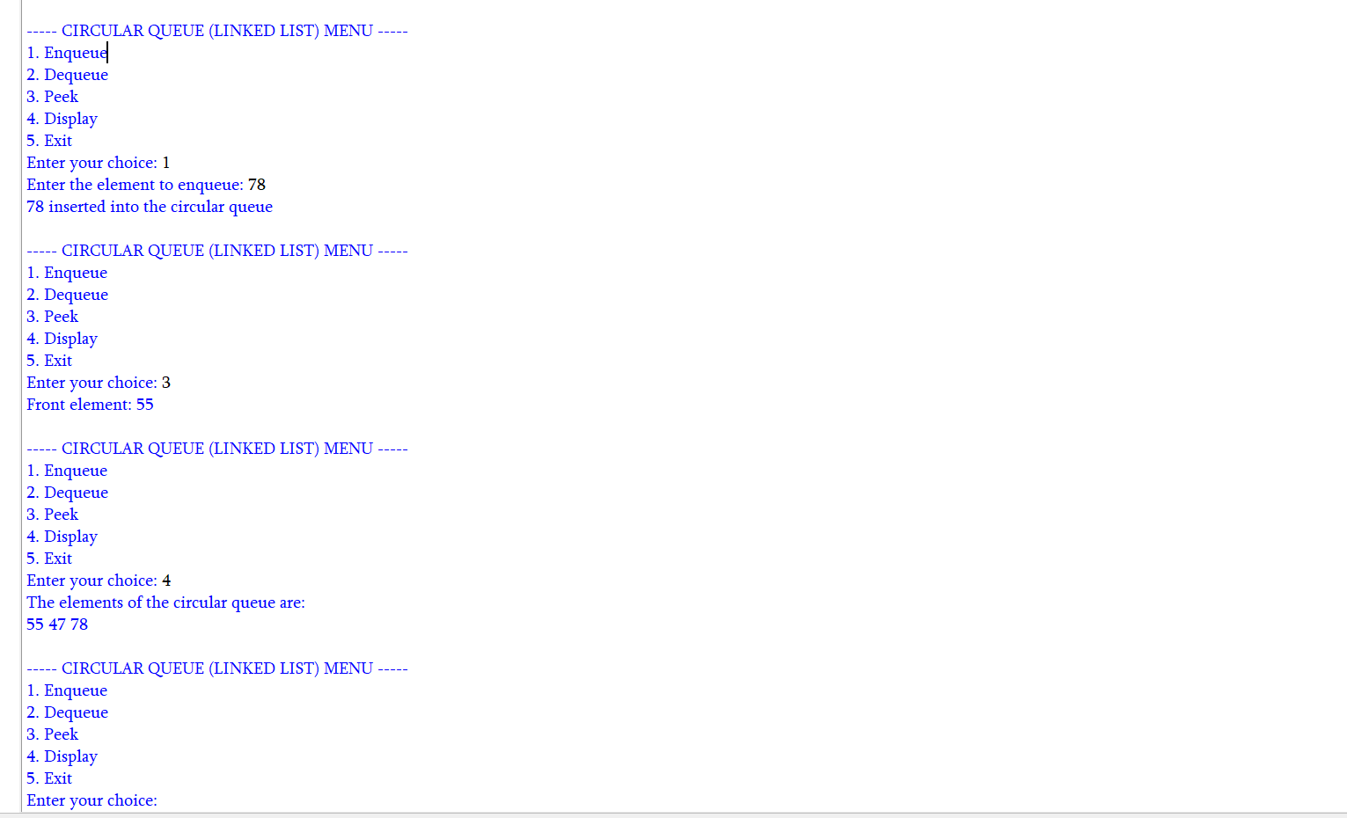

LAB-8:
- ) Aim: write a python program to implement a binary tree with its operations using an array:
Program:
# BINARY TREE USING ARRAY
class BinarytreeArray:
def __init__(self, size):
self.tree = [None] * size
self.size = size
# Insert root
def set_root(self, data):
self.tree[0] = data
# Set left child
def set_left(self, parent_index, data):
child_index = 2 * parent_index + 1
if child_index < self.size:
self.tree[child_index] = data
else:
print("Index out of range")
# Set right child
def set_right(self, parent_index, data):
child_index = 2 * parent_index + 2
if child_index < self.size:
self.tree[child_index] = data
else:
print("Index out of range")
# Preorder Traversal
def preorder(self, index=0):
if index >= self.size or self.tree[index] is None:
return

print(self.tree[index], end=" ")
self.preorder(2 * index + 1)
self.preorder(2 * index + 2)
# Inorder Traversal
def inorder(self, index=0):
if index >= self.size or self.tree[index] is None:
return
self.inorder(2 * index + 1)
print(self.tree[index], end=" ")
self.inorder(2 * index + 2)
# Postorder Traversal
def postorder(self, index=0):
if index >= self.size or self.tree[index] is None:
return
self.postorder(2 * index + 1)
self.postorder(2 * index + 2)
print(self.tree[index], end=" ")
# Level-order Traversal
def level_order(self):
for value in self.tree:
if value is not None:
print(value, end=" ")
# Display Array
def display(self):
print("\nArray Representation")
for i in range(self.size):
print(f"Index {i} : {self.tree[i]}")

# MAIN PROGRAM

tree = BinarytreeArray(7)
# Create the tree
tree.set_root('A')
# Children of A
tree.set_left(0, 'B')
tree.set_right(0, 'C')
# Children of B
tree.set_left(1, 'D')
tree.set_right(1, 'E')
# Right child of C
tree.set_right(2, 'F')

# Display tree
tree.display()

# Traversals
print("\nPreorder: ", end="")
tree.preorder()
print("\nInorder: ", end="")
tree.inorder()
print("\nPostorder: ", end="")
tree.postorder()
Output:
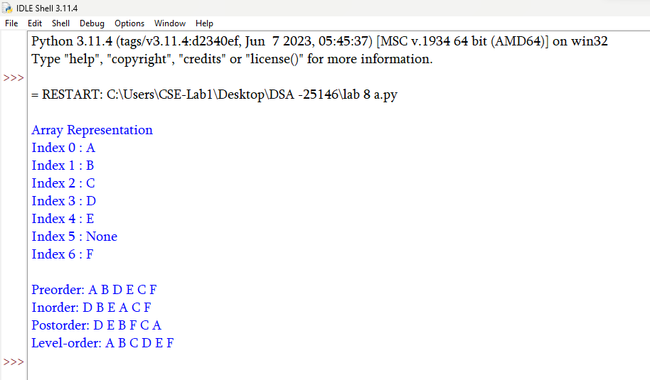

- ) Aim: write a python program to implement a binary tree with its operations using Linked list:
Program:
# BINARY TREE USING LINKED LIST
class Node:
def __init__(self, data):
self.data = data
self.left = None
self.right = None
# BINARY TREE CLASS
class BinaryTree:
def __init__(self):
self.root = None
# Create the binary tree
def create_tree(self):
self.root = Node('A')
# create root
# Left and right children of A
self.root.left = Node('B')
self.root.right = Node('C')
# Children of B
self.root.left.left = Node('D')
self.root.left.right = Node('E')
# Right child of C
self.root.right.right = Node('F')
# Preorder Traversal
def preorder(self, node):
if node is None:
return

print(node.data, end="")
self.preorder(node.left)
self.preorder(node.right)
# Inorder Traversal
def inorder(self, node):
if node is None:
return
self.inorder(node.left)
print(node.data, end="")
self.inorder(node.right)
# Postorder Traversal
def postorder(self, node):
if node is None:
return
self.postorder(node.left)
self.postorder(node.right)
print(node.data, end=" ")
# Level-order Traversal
def level_order(self):
if self.root is None:
return
queue = [self.root]
while queue:
node = queue.pop(0)
# Remove first node
print(node.data, end=" ")
# Add left child
if node.left is not None:
queue.append(node.left)

# Add right child
if node.right is not None:
queue.append(node.right)

# MAIN PROGRAM
tree = BinaryTree()
# Create the binary tree
tree.create_tree()
# Traversals
print("Preorder: ", end="")
tree.preorder(tree.root)
print("\nInorder: ", end="")
tree.inorder(tree.root)
print("\nPostorder: ", end="")
tree.postorder(tree.root)
print("\nLevel-order: ", end="")
tree.level_order()

Output:
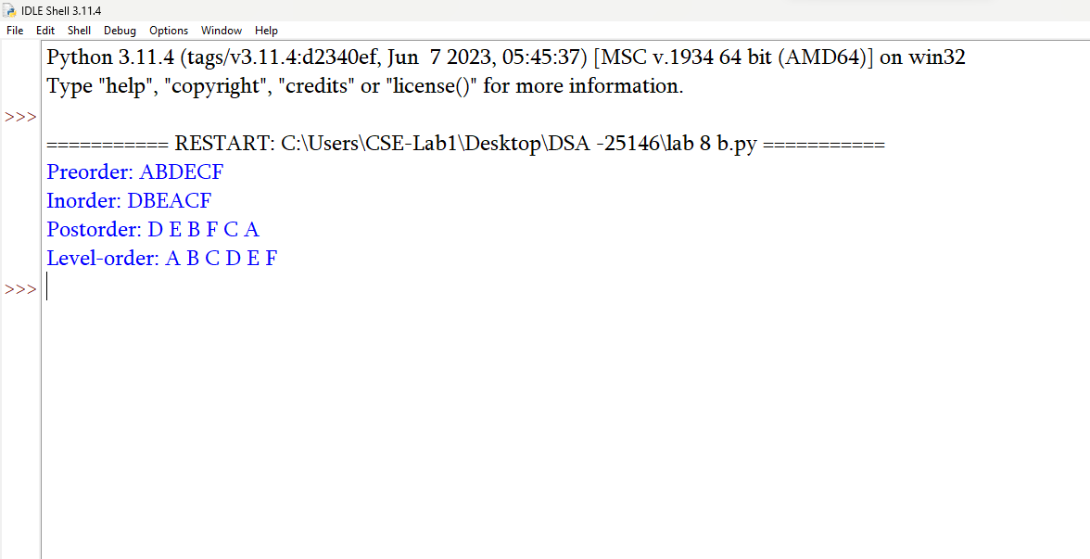
LAB-9:
- ) Aim: write a python program to implement a binary search tree with its operations and traversals:
Program:
class Node:
def __init__(self, data):
self.data = data
self.left = None
self.right = None

def insert(root, x):
if root is None:
return Node(x)
if x < root.data:
root.left = insert(root.left, x)
elif x > root.data:
root.right = insert(root.right, x)
else:
print("Duplicate value is not allowed.")
return root

def inorder(root):
if root is None:
return
inorder(root.left)
print(root.data, end="")
inorder(root.right)

def preorder(root):
if root is None:
return
print(root.data, end="")
preorder(root.left)
preorder(root.right)

def postorder(root):
if root is None:
return
postorder(root.left)
postorder(root.right)
print(root.data, end="")

def find_min(root):
if root is None:
return None
while root.left is not None:
root = root.left
return root

def find_max(root):
if root is None:
return None
while root.right is not None:
root = root.right
return root

def search(root, data):
if root is None:
return None
if data < root.data:
return search(root.left, data)
elif data > root.data:
return search(root.right, data)
else:
return root

def count_nodes(root):
if root is None:
return 0
return count_nodes(root.left) + count_nodes(root.right) + 1

def count_leaves(root):
if root is None:
return 0
if root.left is None and root.right is None:
return 1
return count_leaves(root.left) + count_leaves(root.right)

def count_internal(root):
if root is None:
return 0
if root.left is None and root.right is None:
return 0
return count_internal(root.left) + count_internal(root.right) + 1

def height(root):
if root is None:
return -1
left_height = height(root.left)
right_height = height(root.right)
return max(left_height, right_height) + 1

def delete(root, x):
if root is None:
print("Element not found.")
return None
if x < root.data:
root.left = delete(root.left, x)
elif x > root.data:
root.right = delete(root.right, x)
else:
#case 1 node has no children
if root.left is None and root.right is None:
root = None
#case 2 node has onle right child
elif root.left is None:
root = root.right
#case 3 node only left child
elif root.right is None :
root = root.left
#case 4 node has 2 children
else:
successor = find_min(root.right)
root.data = successor.data
root.right = delete(root.right, successor.data)
return root

def print_level(root, level):
if root is None:
return
if level == 0:
print(root.data, end="")
else:
print_level(root.left, level - 1)
print_level(root.right, level - 1)

def level_order(root):
h = height(root)
for level in range(h):
print_level(root, level)

# MAIN PROGRAM

root = None
while True:
print("\n\n******** BINARY SEARCH TREE ********")
print("1. INSERT")
print("2. PREORDER TRAVERSAL")
print("3. INORDER TRAVERSAL")
print("4. POSTORDER TRAVERSAL")
print("5. FIND MINIMUM")
print("6. FIND MAXIMUM")
print("7. SEARCH")
print("8. DELETE")
print("9. COUNT NODES")
print("10. COUNT LEAVES")
print("11. COUNT INTERNAL NODES")
print("12. HEIGHT")
print("13. LEVEL ORDER TRAVERSAL")
print("14. EXIT")

choice = int(input("Enter your choice: "))
if choice == 1:
data = int(input("Enter the data to be inserted: "))
root = insert(root, data)
print("Element inserted successfully.")
elif choice == 2:
print("Preorder Traversal:", end=" ")
if root is None:
print("Tree is empty.")
else:
preorder(root)
print()
elif choice == 3:
print("Inorder Traversal:", end=" ")
if root is None:
print("Tree is empty.")
else:
inorder(root)
print()
elif choice == 4:
print("Postorder Traversal:", end=" ")
if root is None:
print("Tree is empty.")
else:
postorder(root)
print()
elif choice == 5:
node = find_min(root)
if node is None:
print("Tree is empty.")
else:
print("Minimum element:", node.data)
elif choice == 6:
node = find_max(root)
if node is None:
print("Tree is empty.")
else:
print("Maximum element:", node.data)
elif choice == 7:
data = int(input("Enter the data to be searched: "))
node = search(root, data)
if node is None:
print("Element", data, "is not found.")
else:
print("Element", data, "is found.")
elif choice == 8:
data = int(input("Enter the data to be deleted: "))
root = delete(root, data)
elif choice == 9:
print("Number of nodes:", count_nodes(root))
elif choice == 10:
print("Number of leaf nodes:", count_leaves(root))
elif choice == 11:
print("Number of internal nodes:", count_internal(root))
elif choice == 12:
print("Height of BST:", height(root))
elif choice == 13:
print("Level Order Traversal:", end=" ")
if root is None:
print("Tree is empty.")
else:
level_order(root)
print()
elif choice == 14:
print("Program terminated.")
break
else:
print("Invalid choice. Please try again.")

Output:
